Sanilac County Community Mental Health Authority
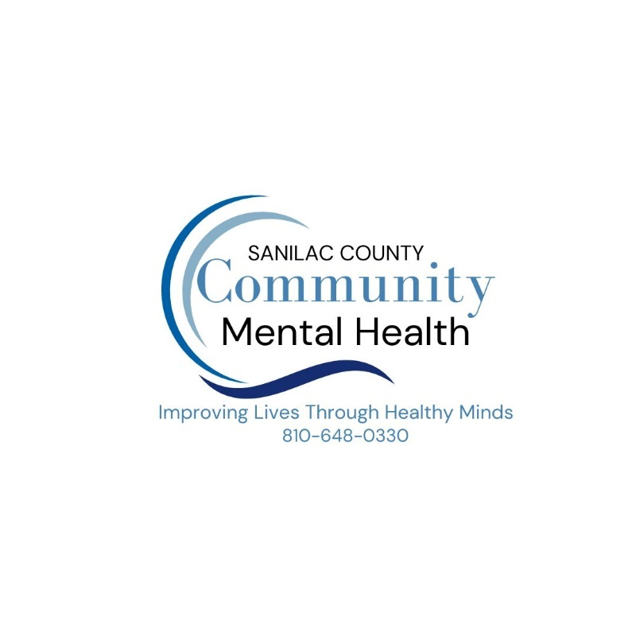
Corporate Compliance Program Plan
FY 2026

Overview
Sanilac County Community Mental Health Authority (Sanilac CMH) has a Corporate Compliance Program to provide quality care for all of the individuals it serves by acting as an internal control. This encourages services that are provided by persons acting in good faith, with a duty of care and safety to the consumers, and promotes honesty, integrity, and high ethical standards. A Corporate Compliance Program Plan is developed annually that includes a description of the Corporate Compliance Program structure and activities.

Corporate compliance plans are required of providers receiving more than five (5) million dollars in Medicaid State Plan monies. Sanilac CMH utilizes resources from the Health Care Compliance Association including the Compliance Program Seven Elements and the Michigan Department of Health and Human Services Office of Inspector General (MDHHS OIG) to develop the following compliance program basics:

- Standards of conduct, policies, and procedures:
  - Written standards, policies, and procedures
- Compliance Office and Committees:
  - Designation of a corporate compliance officer
  - Designation of Corporate Compliance Committee
- Communication and education:
  - Conducting effective training and education
  - Ongoing and effective lines of communication
- Internal monitoring and auditing:
  - Conducting monitoring and auditing
- Reporting and investigating:
  - Responding to detected offenses, implementing corrective action, and issuing discipline as appropriate
- Enforcement and discipline:
  - Implementation of compliance and practice standards
- Response and prevention:
  - Staying current with the law/regulations

Compliance Program Elements

Standards of conduct, policies, and procedures

Mission
Sanilac CMH’s mission is Improving Lives Through Healthy Minds.

Additionally, Sanilac CMH wants to deter fraudulent acts, detect misconduct, and prevent the waste and abuse of government resources and monies. In the spirit of the Medicaid Integrity Rules, everyone has a responsibility to make sure that monies provided for health care are spent on the right individuals, the right providers, and for the right services.

The following mnemonic expresses the Sanilac CMH’s commitment at the very basic level.

- Commit to doing what is right
- Obey regulations and policies
- Make compliance awareness part of everyone’s job
- Practice good conduct
- Learn about compliance
- If in doubt, call the Corporate Compliance office
- Attend training
- Notify supervisors of possible wrongdoing
- Communicate openly and honestly
- Ethics is part of all the activities within Sanilac CMH

Compliance Definitions and Practice Standards

Definitions

Abuse: Provider practices that are inconsistent with sound fiscal, business, or clinical practices, and result in an unnecessary cost to the Medicaid program, or in reimbursement for services that are not medically necessary or that fail to meet professionally recognized standards of care. It also includes beneficiary practices that result in unnecessary costs to the Medicaid program. (42 CFR § 455.2)

Fraud: (Federal False Claims Act, 1863): An intentional deception or misrepresentation made by a person with the knowledge that the deception could result in some unauthorized benefit to himself or some other person. It includes any act that constitutes fraud under applicable federal or state law including but not limited to the Federal False Claims Act and the Michigan False Claims Act. (42 CFR § 455.2)

(per Michigan statute and case law interpreting same): Under Michigan law, a finding of Medicaid fraud can be based upon evidence that a person “should have been aware that the nature of his or her conduct constituted a false claim for Medicaid benefits, akin to constructive knowledge”. But errors or mistakes do not constitute “knowing” conduct necessary to establish Medicaid fraud, unless the person’s “course of conduct indicates a systematic or persistent tendency to cause inaccuracies to be present”.

Waste: Overutilization of services, or other practices that result in unnecessary costs. Generally, not considered caused by criminally negligent actions but rather the misuse of resources.

Practice Standards

The Affordable Care Act (2010): This Act requires Sanilac County CMH to have a written and operable compliance program capable of preventing, identifying, reporting, and ameliorating fraud, waste, and abuse across Sanilac County CMH’s provider network. All programs funded by Sanilac County CMH subcontract provider organizations and practitioners, board members and others involved in rendering covered services, fall under the purview and scope of the compliance program.

The Federal False Claims Act (1863): This Act permits individuals to bring action against parties which have defrauded the government and provides for an award of half the amount recovered. The Act contains protection from recrimination against those who report, testify, or assist in investigation of alleged violations (whistleblowers) and provides a broad definition of “knowingly” billing Medicaid or Medicare for services which were not provided, not provided according to requirements for receiving payment, or were unnecessary. The most common criminal provisions invoked in health care prosecutions are prohibitions against false claims, false statements, mail fraud and wire fraud.

Penalties are:
- 5 years imprisonment
- Fine of $250K for an individual or $500K for an organization, or two (2) times the gross gain or loss from the offense, whichever is greater
- Mandatory exclusion from participation in Federal Healthcare Program

The Michigan Medicaid False Claims Act (1977): An act to prohibit fraud in the obtaining of benefits or payments in connection with the medical assistance program; to prohibit kickbacks or bribes in connection with the program; to prohibit conspiracies in obtaining benefits or payments; to authorize the attorney general to investigate alleged violations of this act; to provide for civil actions to recover money received by reason of fraudulent conduct; to prohibit retaliation (against whistleblowers); to provide for certain civil fines; and to prescribe remedies and penalties.

The Anti-Kickback Statue (1972): Prohibits the offer, solicitation, payment, or receipt of remuneration, in cash or in kind, in return for or to induce a referral for any services paid for or supported by the Federal Government or for any good or service paid for in connection with an individual’s service delivery. There is a penalty for knowingly and willfully offering, paying, soliciting, or receiving kickbacks; violations are felonies; and maximum fine of $25K, imprisonment of up to 5 years.

HIPAA (1996): Expands the definition of “knowing and willful conduct” to include instances of “deliberate ignorance” such as failure to understand and correctly apply billing codes. HIPAA calls for a prison sentence of up to 10 years.

Sanilac County CMH Policy and Procedure Development & Review

The Corporate Compliance Officer, with input from the administrative and regional committees and other resources, will determine what policies and procedures, if any, need to be developed to augment practices already in place to help ensure legal compliance. These policies and procedures will be continually reviewed on an annual basis and revisions will be made when deemed appropriate.

Sanilac County policies and procedures include:
- BA032 Corporate Compliance Program
- BA021 Code of Ethics
- BA008 Agency Leadership/Conflict of Interest
- DA1005 Corporate Compliance Complaint, Investigation and Reporting Procedure
- RR005 Confidentiality and Disclosure of Information
- BA141 Utilization Management Program
- BA045 Network Management and Monitoring Plan
- DA1054 Network Monitoring
Sanilac CMH does facilitate ongoing review of the compliance policies to ensure that all content is aligning with federal and contractual requirements.

Code of Conduct

The Code of Conduct serves to function as a foundational document that details the fundamental principles, values, and framework within Sanilac CMH. The Code of Conduct articulates the agency’s commitment to promote honesty, integrity, and high ethical standards in the work environment and to comply with all applicable Federal and State standards as well as other legal and ethical obligations. The standards not only address compliance with statutes and regulations, but also set forth broad principles that guide employees. Sanilac CMH personnel are expected to be familiar with and are obligated to adhere to the standards set forth in this Code of Conduct or incorporated by reference herein and in Sanilac CMH policies.

Corporate Compliance Office and Committees

Due to Sanilac CMH size, the administrative group has taken on the responsibility of being the Compliance Committee which oversees the organization’s compliance program. Members include the Chief Executive Officer, Chief Financial Officer, Chief Operations Officer, Chief Information Officer, Chief Program Officer (Corporate Compliance Officer), Human Resource Manager, Recipient Rights Officer, and the Executive Administrative Assistants.

Sanilac CMH has responsibility for approving and monitoring the Quality Assessment and Performance Improvement Program (QAPIP). To implement the QAPIP (QI Program), Sanilac CMH has established the Quality Improvement Committee which has designated the Corporate Compliance Committee to address the agency’s compliance goals. Members include the Corporate Compliance Officer and administrative staff. Committee functions are further outlined in the Sanilac CMH Data Evaluation and Monitoring Policy.
Sanilac CMH has created a Corporate Compliance team which includes the Corporate Compliance Officer, Security and Privacy Officer, Network Provider Privacy Officer, and designated back up. The Corporate Compliance team has been designated as the group, within CMH, who are responsible for overall development, implementation, and administration of Sanilac CMH’s Corporate Compliance Program Plan including enforcement activities. The Corporate Compliance team reports directly to the Chief Executive Officer and the Board of Directors and is responsible to ensure:

- Sanilac CMH personnel are receiving education and training regarding the Sanilac CMH Corporate Compliance Program Plan and that such education and training is documented;
- Competency is maintained as received through effective and ongoing training;
- Prompt response to detected offenses and that a complaint is initiated to report, investigate, and follow up on any suspected fraud, abuse, waste, and/or other improper conduct;
- Appropriate reporting/referrals are made as a result of complaint investigations;
- Notification is provided to the Region 10 PIHP and/or MDHHS OIG regarding ongoing program integrity activities and all allegations of Medicaid fraud/waste/abuse;
- Guidance is provided on program integrity activities to subcontracted entities and ensure requirements are included in any subcontracts;
- Policy development and implementation;
- Code of Conduct development and implementation;
- Provisions for internal monitoring and auditing; and
- Dissemination of appropriate contact information for reporting.

Communication and Education

The Sanilac CMH facilitates ongoing efforts to support the Sanilac CMH through training and communications. The following describes those efforts.

Sanilac CMH requires all personnel to participate in programs of training and continuing education as needed with respect to the Corporate Compliance Program. Sanilac CMH also maintains efforts to support clear communication regarding the Corporate Compliance Program. All personnel are expected to cooperate with the development, implementation, and ongoing administration of the Corporate Compliance Program plan.

Sanilac CMH has developed a training curriculum and a schedule for both initial and ongoing (annual and as needed) employee training. All Sanilac CMH employees (direct and network provider staff) are expected to follow the mandatory training requirements for corporate compliance. The Corporate Compliance Officer follows the Statewide Compliance Officers Workgroup in development and content management of training reciprocity for statewide implementation.

Additionally, Sanilac CMH has developed an ongoing training plan for all employees regarding potential security risk areas. This training is incorporated into all staffs’ training plans as an effort to educate staff on potential security risks.

A corporate compliance page is posted on Sanilac CMH’s internal and external websites. The webpages include important information regarding corporate compliance, Sanilac CMH policies and procedural assistance on how to report a compliance complaint.

Sanilac CMH Corporate Compliance Office notifications are sent to agency staff and provider network designees on an ongoing basis regarding continued efforts to ensure safeguarding the privacy and security of protected health information is a priority. Notifications also include regulatory updates, policy changes, and other related compliance matters.

Additionally, Sanilac CMH provides ongoing updates, as needed, to the Sanilac CMH Board. Furthermore, Sanilac CMH provides a compliance focused training to the Sanilac CMH Board annually which provides education in the area of corporate compliance.

Complaint Process

Sanilac CMH supports open lines of communication and, as such, maintains a written compliance procedure (Corporate Compliance Complaint, Investigation and Reporting Procedure, DA1005) that includes the process of filing complaints, investigative procedures, corrective action plans when necessary, and discipline or other consequences that are deemed appropriate.

Internal Monitoring and Auditing

Sanilac CMH engages in multiple monitoring and auditing activities to discourage and detect possible corporate compliance violations.

If Sanilac CMH finds what appears to be improper activity on the part of any personnel or uncovers inappropriate practices or procedures during monitoring activities, Sanilac CMH will undertake reasonable and appropriate steps to resolve the problem. Such steps may include but are not limited to stopping all billing related to the problem until such time as the offending practices are corrected; initiating an appropriate corrective action plan; taking disciplinary action against the individual or individuals whose conduct violates the Corporate Compliance Program or applicable laws; notification to government agencies; and repayment of improper payments.

Below are descriptions of some of Sanilac CMH’s current monitoring and auditing processes:

- Through the Sanilac CMH Corporate Compliance team, members address maintaining a cohesive strategy for reporting corporate compliance complaints across the CMH and makes recommendations on compliance with regulatory requirements.
- Conducts data mining activities on an ongoing basis focusing on appropriate use of Medicaid funds by Sanilac CMH Network Providers.
- Conducts specialized audits on an ongoing and as needed basis identified through compliance complaints and / or audit and complaint referrals.
- Conducts primary source verification checks initially and monthly to ensure that all clinical staff, contracted entities, owners, and managing employees are not excluded from participating in Federal and State funded health care programs.
- Conducts an annual network monitoring review which includes desk audit reviews, onsite visits and record reviews. Additionally, Sanilac CMH will review an aggregate report of the findings from the annual network monitoring review to identify trends and develop interventions including plan of corrections when appropriate.
- Receives and reviews network provider quarterly compliance complaint reports as well as provider fraud referrals.

Reporting & Investigating

It is the responsibility of all personnel to report to Sanilac CMH his or her good faith belief of any violation. At the request of the personnel reporting the violation, Sanilac CMH will provide such anonymity to the reporting person as is possible under the circumstances in the judgment of Sanilac CMH. Sanilac CMH and its personnel will not retaliate against any individual for good faith reporting of a suspected violation.

The Corporate Compliance Office responds promptly and thoroughly to reports by personnel, or others, that personal or independent contractors are engaging in activity that may be contrary to the corporate compliance plan; that such an individual may be submitting bills or claims in manner which does not meet the Medicaid guidelines; that an individual is not complying with compliance policies and procedures; or that problems were discovered during monitoring activities.

All complaints are tracked and analyzed by the Sanilac CMH Corporate Compliance team. Suspicion/ non-suspicion are the possible outcomes that relate only to fraud, waste, and abuse violations, where substantiated/un-substantiated are the possible outcomes for all other violations.

Sanilac CMH reports all activities related to program integrity to the Region 10 PIHP on a quarterly and annual basis. Additionally, the Sanilac CMH coordinates with the PIHP and/or the MDHHS OIG for potential fraud referral presentations to the Medicaid Fraud Control Unit (MFCU) when there is an identified suspicion of fraud within the Sanilac CMH Network.

Furthermore, Sanilac CMH, through the Corporate Compliance team, reports monthly updates on committee goals to the Quality Improvement Committee. Sanilac CMH also reports ongoing and regular updates to the Region 10 PIHP who then reports to the Regulatory Compliance Committee and PIHP Board.

Enforcement and Discipline

Sanilac CMH maintains elements described above to enforce the Sanilac CMH Corporate Compliance Program and act as an internal control.

Response and Prevention

To prevent and deter corporate compliance violations, the Sanilac CMH Compliance Team will engage in multiple prevention activities throughout the fiscal year. Examples include:

- Sanilac CMH Board and Administrative Committee meetings to address regulatory issues, regional complaint data, and reporting.
- Sanilac CMH Corporate Compliance team participation in the Corporate Compliance Program Plan.
- Policy and procedure annual review when there are policy revisions.
- Training for Sanilac CMH staff. Examples include New Employee Orientation Training for all new Sanilac CMH staff, celebrating National Compliance & Ethics Week to showcase the important role in maintaining a compliance organizational culture, and Potential Security Risk Trainings to Sanilac CMH staff.
- Communications to staff including updates on any relevant compliance topics and quarterly corporate compliance reminders.
- Maintaining Business Associate Agreements with all contracted entities that have access to Protected Health Information (PHI).
- Maintaining the compliance information on Sanilac CMH’s websites.
- Identification and implementation of Sanilac CMH Corporate Compliance team goals.

Conclusion

The Sanilac CMH FY2026 Corporate Compliance Program Plan describes the structure and activities for the fiscal year. This Program Plan will be reviewed and approved by the Sanilac CMH Board prior to implementation.

